



**ACTIVITIES AT KENCH HILL**

The Kench Hill Charity is an inspirational outdoor education centre in the heart of the Kent countryside. We pride ourselves on providing a unique learning environment where children feel safe and excited to challenge themselves and lead their own learning. Working in partnership with school teachers we plan a bespoke cross-curricular programme that is accessible to all students and has defined learning intentions and class objectives.

Please discuss your visit with us in advance so we can tailor a programme that best suits your group, whether your aims are curricular and/or social and emotional development. We constantly review, improve and develop new activities, most of which are available all year round and in all weathers.

Our core values:

**D** : diversity both in what we do and in nature

**I** : inclusion for all

**N** : nature and nurture

**E** : environmental education is at the heart of all we do

**DINE with us!**

**Key Information about the activities at Kench Hill**

Most site-based activities are for 10-12 participants rotating around two or three different activities running concurrently eg. 30 children take part in 3 x 1-hour activities, such as bread-making, gardening & orienteering. All of the below activities have been designed so children can safely develop the knowledge, skills and understanding required by the school curriculum at **Key Stage 1, 2 and 3** through experiential, child-centred learning.

Lessons are supported by detailed teaching plans, available upon request. Risk assessments for all activities are listed in the Health & Safety Manual which can be downloaded from the [website](https://kenchhill.co.uk/school-residentials/). Many activities are suitable and/or can be adapted for SEN and **Key Stage 3**.

We incorporate cross-curricular themes in ESD (Education for Sustainable Development), PHSE and Citizenship in all aspects of a visit. Healthy eating and sustainability are holistic elements of the Kench Hill experience, with our kitchen garden forming an important focus. Outcomes fit Every Child Matters framework – ***Be Healthy, Stay Safe, Enjoy & Achieve, Make a Positive Contribution.***

We have a minibus (16+driver) for shuttling to local villages, beaches etc. This is an economical option for groups as an alternative to an additional coach trip. The minibus is charged at £1.50 per mile.

**Contents**

1. Art/Design Technology
2. Geography
3. Science
4. Cross-curricular activities
5. Physical education
6. Trips away from Kench Hill

**KEY * Suitable for wheelchair access. ~ Suitable for wet weather.**

1. **ART & CRAFT / DESIGN TECHNOLOGY** 

**Bread making * *~ KS1, 2 or 3***

Grind wheat using pupil energy with Kench Hill’s purpose-made millstone. Find out when mankind first discovered wheat. The tasty wholemeal rolls are eaten as an evening snack. Link to historical study of Saxons, Victorians or World War 2, or healthy eating in PSHE. Enhance the topic with a visit to a local windmill or Rare Breeds Centre (additional charge).

**Group size: Max 12 Time: 1 hr Tues/Weds only Cost: FREE**

**Science:** Materials & their properties; Unit 6 Micro-organisms **Maths:** Measurement **History:** Saxons

**DT:** Unit 5B Bread; Working with Tools and Equipment. **PSHE:** Healthy lifestyle

**Links with:** Clay-Play, Cookery, Gardening, Victorians, Saxons

**Environmental Art * ~ KS1, 2 or 3**

Heard of Andy Goldsworthy? Children will be inspired to use found natural materials– leaves, twigs, berries, clay, stones - to create pictures, abstract or on a theme like “wildlife”. A popular team-building activity. Alternatively, close observational drawing focuses concentration and improves skills, stimulated by the beautiful flowers or buildings at Kench Hill. Make a mural with rolls of paper and paint for a wet weather option.

**Group size: 10- 30 Time: 45 mins+ Cost: Free**

**Art:** Investigating and making



**Shelter-Building and Bush craft * KS1, 2 and 3**

Making shelters is an inventive fun activity which is ideal for small group work. It covers the Year 6 Scheme of work for DT and is also an excellent team-building activity ideal for PSHE. Using a variety of materials the children will plan their design and then create it. Finally they will carry out tests and discover possible improvements. It can lead to further in-depth investigation of built structures. Link with camp cookery and Wilderness First Aid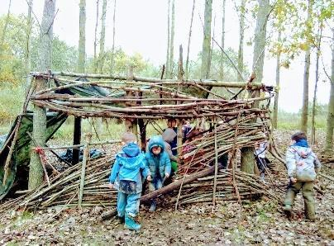

**Group size: 10-18 Time 45 mins+ Cost: FREE**

**DT:** Unit 6A Shelters, Working with Materials **PSHE:** Developing confidence; developing good relationships

**Willow-weaving * ~ KS2 or 3 (SEASONAL)**

Design and create an individual dreamcatcher or head dress to take home, using our home-grown osier (basket-making) willow.

**Group size: Max 12 Time 30 mins- 1 hour Cost: FREE**

**DT:** Working with Materials **Science**: Living things - Plants

**2. GEOGRAPHY**

**Orienteering 1 (Map reading & Co-ordinates)**  **Orienteering 2 (Compass Skills) \*** **KS1, 2 or 3**

Learn how to read orienteering maps to discover hidden clues in Kench Hill’s garden, racing against other teams. Accuracy and teamwork are essential - kids love the challenge and the chance to learn a useful new skill. Develop the activity further with a session on compass skills. Extend further with exciting geocache exploration in local woodlands, or combine with a trip to Bedgebury Pinetum to use their trails.

**Group size: 10-15 Time: 1 hour each session Cost: FREE**

**Geography:** Skills **Maths**: Shape, space and measures **PE:** Outdoor and adventurous activity

**Comparative Locality study \***  **KS3**

Go by mini-bus to Woodchurch or Appledore villages, or the small towns of Rye and Tenterden. Investigate similarities and differences between urban and rural, including traffic survey, discovery trail, optional visit to Windmill or local museums. Historical and modern maps.

**Group size: Whole class, split into groups of 15 Time: 2 -4 hrs Cost: £1 per pupil Woodchurch Museum donation, plus transport (£10-20 per group).**

**Geography:** Enquiry and skills; Places; Environmental change. Unit 9: Village settlers/Urbanisation

Unit 12: Should the High St be closed to traffic? (Rye)

Unit 13: A contrasting UK locality – Village study (Woodchurch or Tenterden)

Links with: History; Bread-making



**Local Walks**   **KS1/2/3**

Always fun and memorable. Long or short, through a river valley and farm, for map work or collecting, we have a walk to suit your needs. Ideal as an introduction on Monday afternoon or a more leisurely pace during the week. Raincoats and wellies available for all sizes!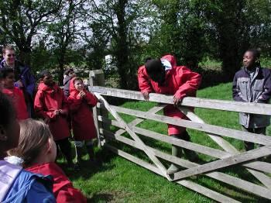

* *With prior arrangement we can choose a suitable route for wheelchair users.*

**Group size: 15-40 Time: 2 hrs – whole day Cost: FREE**

**Geography**: Enquiry; Skills; Unit 14 Investigating rivers; Themes: Local settlements, fieldwork investigations

**Science:** Living things in their environment **PE:** Outdoor and adventurous activities

**Geology - Fossil Hunting**

Learn about the study of rocks and their formation. Including the Earth and its formation. Collect samples of earth and identify the local types.

Go fossil hunting at the beach!

**Group size: 15-40 Time: 2 hrs – whole day Cost: FREE**

**Geography**: Enquiry; Skills, Fieldwork investigations

**PE:** Outdoor and adventurous activities

**4. SCIENCE**

**Cookery -** **Food for thought * ~ KS1, 2 or 3** 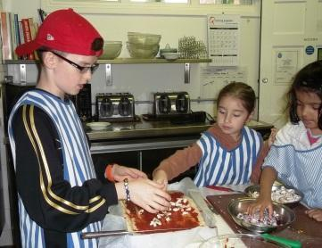

Help prepare your own meal! Learn to make tasty recipes using fresh ingredients eg. soups, fruit salad, pizzas, biscuits. Work with our staff to learn where food comes from, how it grows and to cook a nutritious meal. Even the fussiest eaters will try their own fare. Link with Gardening, Bread-making.

**Group size: Max 10 Time: 1 hr Cost: FREE**

**Science:** Materials and their properties; Green plants; Humans (Nutrition and Health)

**DT:** Working with Tools and Equipment **Maths:** Measurement **PSHE:** Healthy lifestyle; Hygiene

**Links with:** Gardening

**Minibeast madness (Pond-Dipping & Bug hunts) \*** **KS1/2** 

Consolidate learning on classification, adaptation, food chains, life cycles and interdependence by searching for animals from wheelchair-accessible platforms over our large ponds, hedgerows and log piles. Use observational skills to develop scientific enquiry, ask questions and set up real investigations. Use our microscopes, tanks, ID guides and other equipment to devise experiments to discover more about animal behaviour or test an hypothesis. April-November for best results!

**Group size: 8-12 Time: 1 hr+ Cost: FREE  
Science:** Life processes and living things; Unit 4B Habitats; Unit 5 Enquiry in an environmental context



**Terrific Trees \***  **KS2/3**

Wood is good! Trees provide a source of investigation all year round. Kench Hill’s garden has a variety of evergreen and broad-leaved species. Develop scientific skills through close observation; study variation, classification, seed dispersal and reproduction. Investigate how trees affect the environment. Make maths fun by measuring and estimating. Make rubbings or use autumn leaves for spectacular environmental art. Visit local woods to explore woodland habitats and discover clues about the inhabitants.

**Group size: 8-12 Time: 1 hr+ Cost: FREE (minibus trips extra)**

**Science:** Living things in environment - Adaptation, Interdependence; Green plants; Variation & Classification

**Maths:** Measures, problem-solving **Art and Design**

**Go Batty! *~ KS2/3**

We DO have bats in the belfry at Kench Hill! When the sun goes down the bats come out in search of prey. What do they eat? Where do they live? How do they communicate? Take a night walk around the Centre and watch these fascinating mammals perform an acrobatic display in search of dinner. Use a bat detector to hear them echolocate. Learn about life cycles, interdependence and food chains. 

**Apr – Oct only (bats hibernate!) Group size: Any Time: 45 min at dusk – times vary. Cost: FREE**

**Science:** Learn about Mammals, Classification, Food chains



**Astronomy and campfire * ~ KS1,2 or 3**

Take advantage of frequent clear, dark skies using the naked eye and binoculars to observe a galaxy of glittering stars rarely seen in a light-polluted city. Spot the Milky Way overhead, observe the passage of the moon and lengthening of shadows. Be astounded at the vastness of Space. Planetary bodies can be used in a Classification activity (suitable for wet weather/day-time). Combine with a bat walk in summer or a night walk at all times.

**Group size: Any Time: 30 mins+ Cost: FREE**

**Science:** Earth and beyond; Classification

**Amazing animals! Animal adaptations* ~** 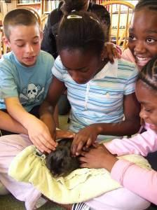

One of the most popular sessions. Learn about adaptations for survival and life processes by getting close to living and stuffed animals and drawing a scientific diagram. Groom and walk the ponies, meet our friendly guinea pig, rabbits and Centre dog. A wonderful stimulus for children who rarely get a close encounter with real animals, and a variety of stuffed specimens provides an opportunity to study form and function in detail, for science and/or observational art activities. Essential before a trip to Rare Breeds Centre or farms.

**Group size: 10-15+ Time: 1hr+ Cost: FREE**

**Science:** Life Processes and Living Things; Living Things in their Environment; Adaptations; Classification

**Animal Care*~**

The daily feeding of Kench Hill’s full-time residents is a popular morning ritual in which all children take part, teaching care and respect for living things, as well as a real demonstration of food chains, life cycles and recycling! .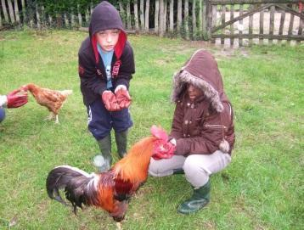

**Group size: Max 10 Time: 20 minutes at 8.30am Cost: FREE**

**5. CROSS-CURRICULAR & ESD ACTIVITIES**

**Earth Education * ~ KS2**

A multi-sensory approach in environmental education encourages children to use all their senses to observe, and foster respect and understanding of the natural world. Blindfold Walks, Smelly Cocktails, Nature’s Palettes, Micro-Nature trails, Magic Spots, Munch Monitors – a wide range of activities to suit different learning styles. Reinforces learning in Science ie concepts such as interdependence, adaptation and feeding relationships. Can be done as a whole day in a local habitat eg woodlands, or individual activities at any time of the day.

**Group size: Any: 30 mins-whole day Cost: FREE**

**Gardening \*** **~ KS2**

Harvesting (and tasting) the wholesome produce. There are always tasks to do, whatever the season or weather – weeding, sowing, picking, digging, potting. Learn about composting, plant life cycles, how food is produced, even in winter in our polytunnel. Our garden tutor will encourage even the most vegetable-averse child to taste healthy food. Link with Cookery -use the fresh fruit and vegetables to help prepare a nutritious meal for the whole class. 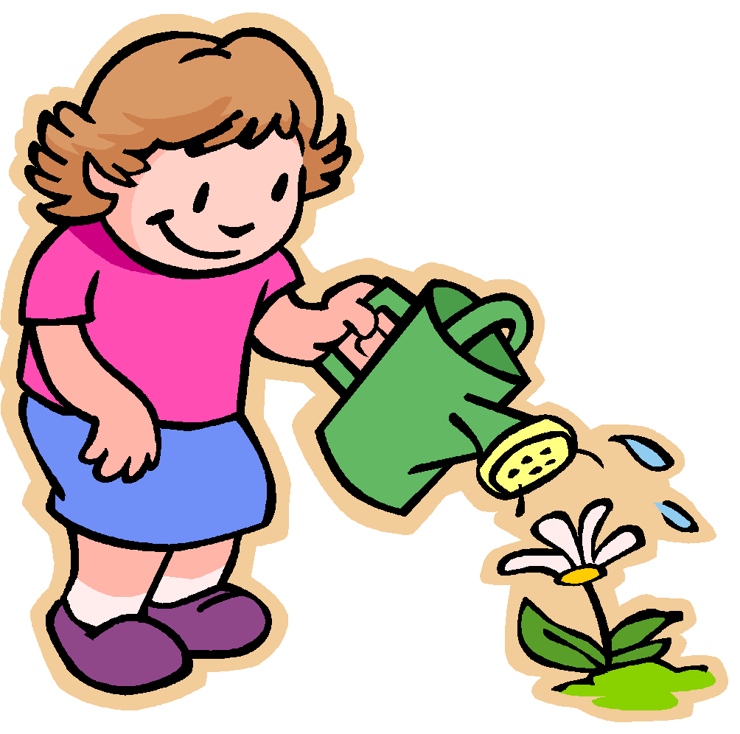

**Group size: 10-12 Time: 1 hr+ Usually Tuesdays Cost: FREE**

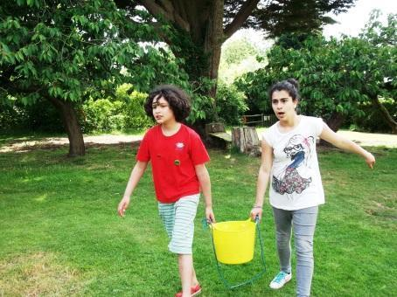

**Water Game and Challenges * ~ KS2**

Learn why clean water is a precious commodity which we can take for granted, but is in short supply for many people in the world. Consider global development issues as you take part in a fun team game collecting water for your ‘family’, facing pitfalls and hazards along the way.

Links with: Shelter-building; Stream walk; Gardening

**Group size: 8-14 Time: 1 hour Cost: FREE**

**Kench Hill Cleudo * KS2**

Who stole the Kench Hill prize cake! Working in teams, children will become detectives, completing challenges, interviewing suspects (teachers) and playing along with the storyline. Staff and children get the chance to dress in fancy dress and explore the house.

Links with: Team work, drama, role play, creative writing, observation, cross curricular themes

**Group size: 15-40 Time: 1 hour Cost: FREE**

**6. PE & ADVENTUROUS ACTIVITIES**

**Swimming* ~ KS2**

Great fun, good exercise and a relaxing (and tiring!) start to the week. Tenterden Leisure Centre’s indoor pool can be reached by foot or minibus and features a wave machine, Jacuzzi and slide, great fun both for swimmers and non-swimmers. There is a good playground adjacent to the pool. Monday afternoons only (term-time). 

**Group: Whole class Time: 2 hrs Cost: £5 per child. Adults free**

**PE:** Swimming activities

**Archery * Year 5+**

1+ hour Have-A-Go session. An introduction to the basics of archery, coaching to load, shoot and collect arrows. The lesson will include a safety briefing, coaching session and team games. Focusing on learning a new skill, resilience, patience, practice and hand eye coordination. 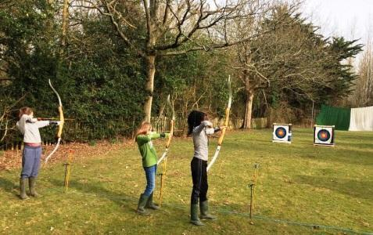

**Group: 10-12 Time: 1 hrs Cost: FREE for resident groups**

The session cannot run in wet or windy weather

**PE:** Outdoor adventurous activities



**Team-building and problem solving games * KS2/3**

We can provide all the resources needed to develop physical and social skills. Why not make team-building and PSHE outcomes the focus of your week?

* **Parachute games** are great for learning how to work together as well as developing coordination.
* **Environmental games** are usually non-competitive, an excellent way to reinforce concepts in science as well as improving social skills.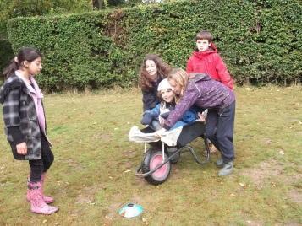
* **Team Game challenge** is a set of 4-6 x 10-minute physical and problem-solving games eg The Snake Pit or The Tyre Challenge, which groups of 6-7 children complete in rotation, earning points as they go. Which team will be the ultimate winner? Who will prove to be a natural leader?
* **Mini-Olympics** No physical prowess required in this set of games suitable for indoors or out. Fun for all, ideal for groups with special needs and younger children. This is a very popular way to finish the week on the last day.
* **Blind obstacle course** Walk through our spooky obstacle course at night or with blindfolds. Can you trust your guide to take you safely round?
* **Water chute game** Use bamboo pipes to collect water – but you have to work together!

**Group: Any Time: Up to 1 hour Cost: FREE**

**Playing Field \***

* **The linear trail** in the field tests all levels of physical fitness.
* Children love playing **football** or **cricket** on the clean, green grass.
* We have equipment for **badminton**, **tennis**, **volleyball,** simple **croquet** and **boules**. In wet weather make use of table-tennis table and table football in the Games Hut.

**Sports day, circus skills and garden games * KS1, 2 or 3**

Why not organise a half-day of team sports with a Kench Hill theme, to suit all abilities and aptitudes? Welly-throwing, egg & spoon, wheelbarrow races, fun relay races, rounders – we have all the equipment you need. Perfect way to end the week! Alternatively, in wet weather indoor team sports can be arranged, making use of our equipment such as table tennis, table football and skittles.

**Group: Any Time: 1hr + Cost: Free PE:** Athletic activities and Adventurous Activities



**Bouldering wall and Night Line * KS2/3**

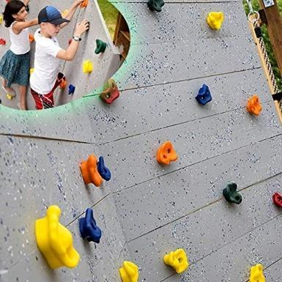

A fun and challenging activity that focuses on trust, support and responsibility. Students work in pairs to navigate the Night line course guiding their blindfolded partner around the obstacle course. They then take on the bouldering traverse wall, encouraging and spotting their partner.

**Group: Half class (15) Time: 1 hr Cost: FREE**

**PE:** Outdoor adventurous activities and team building

**Pedal Go-Karting * KS2/KS3**

Whizz around the Kench Hill grounds in our brand new 2-seater Pedal Go Karts.

Children create their own courses and work together in pairs with one driving and one navigating.

**Group: Under 10 Time: 1 hr Cost: FREE**

**PE:** Outdoor adventurous activities and team building

**7. Day Trips**

**Beach trip (Camber Sands or Pett Level) * KS1, 2 or 3**

Swimming, Paddling, Sandcastle making, kite flying. From £3 per child for travel

**Port Lympne Safari Park** **\* KS1, 2 or 3**

From £16 per child for the day including travel. (Adults free per 8 children).

Home to over 900 animals, across 75 species, including giraffes, lions, tigers, gorillas and camels. Includes a Safari ride through the park, keeper talks and feeding exhibitions. Also, play and activity areas and the UK’s largest model Dinosaur exhibition ‘The Dinosaur Forest’. 

**Rare Breeds Centre** **\* KS1 or 2**

The Rare Breeds Centre is a working 100-acre farm and tourist attraction based in Woodchurch, Kent. Surrounded by the beautiful Kentish countryside, The Rare Breeds Centre is home to many rare and native breeds of farm livestock. Activities include the Discovery Garden, the woodland walks, the outdoor playgrounds and assault courses. Tractor-trailer rides and 'Meet the Animal' sessions in the Children's Barn.

From £13 per child (Adults free)

**Go Ape at Leeds Castle KS2 or 3**

An hour long session of high ropes and zip lines in the forest canopy.

From £18 per person (Staff free)

**Leeds Castle KS1, 2 or 3**

Leeds Castle in Maidstone, rises majestically from the water in the stunning Kentish countryside. With its riveting history serving six of England’s medieval queens to its elaborate transformation into an elegant 20th-century retreat by Anglo-American heiress Lady Baillie, Leeds Castle’s rich heritage has secured its place as one of the most visited historical attractions in Britain.

Two thrilling playgrounds; Knights’ Stronghold Playground, and the Squires’ Court Playground, a challenging Maze with a mythical underground Grotto and the Bird of Prey Centre where you’ll have the opportunity to get up close and personal with these beautiful creatures.

From £14 per child (Adults free)

**Bodium Castle KS1, 2 or 3**

Step into history at Bodiam Castle. This 14th-century moated castle with a ruined interior features spiral staircases, battlements and a portcullis.

From £3 per child (Adults free)